**Manipulating Traffic flow using TLOCs**

**Topology Used:**

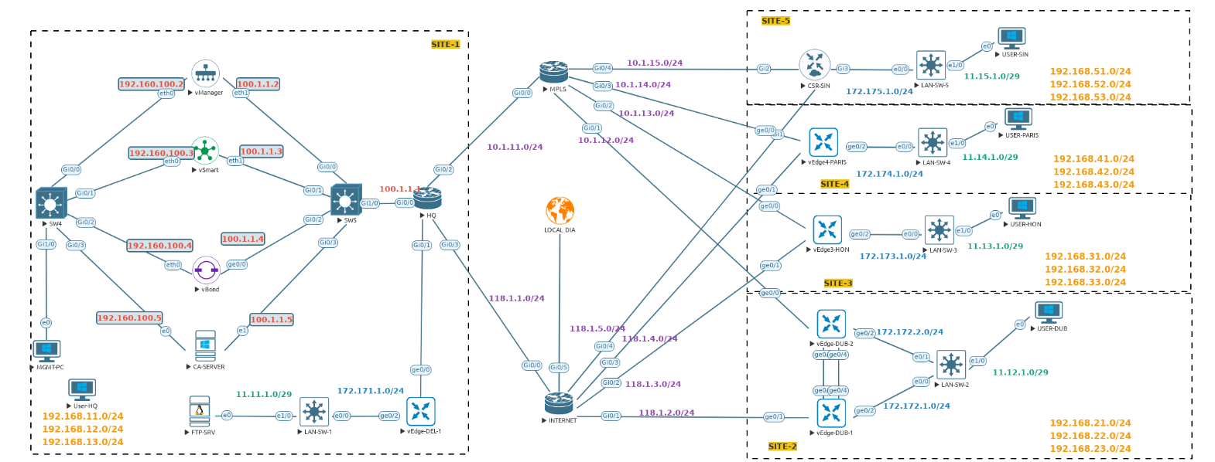

Requirements:

- Paris should only the MPLS TLOC as the preferred color while communicating to Dubai.

The Internet TLOC should be backup TLOC.